Toyota Surf/4Runner Automatic Disconnecting Differential (ADD) 4WD system troubleshooting notes
January 2023:
From many weeks of reading online, mainly on discussion boards and forums from the mid-2000s, the most common 4WD problem in the 4Runners and Surfs of 1996-1999 models are as follows:
- Position sensors at the front differential (one sensor) and the transfer case (two sensors) become faulty and give error signals to the 4WD computer. These are tricky to remove, requiring a 27mm socket with a provision for passing over the wires.
- 84222-12010 Transfer indicator Switch; part # for the front diff sensor - 84222-35070
- Switches and connections should also be cleaned with contact cleaner!
- Breaks in the vacuum line to the front actuator (which links the front diff to the shafts with a sliding sleeve)
- The rear transfer case actuator motor (engages the front drive shaft)…this can seize due to hardened grease, or rust especially if the breather pipe falls off (which happened in my Surf…but then oil got in, how???). See Section 7. Also the actuator itself can seize (fork?shaft?). Reinstalling the actuator can be tricky as electrics and timing need to be properly aligned
- The rear actuator can be tested using a 12v source of power, and should move freely back and forth. ‘Jumpering’ the actuator may help lubricate it if had not been used for a long time (Owners Manual recommends driving at least 16km a month in 4WD modes!)
- The 4WD computer is rarely at fault. So the order of occurrence of failure is: 1) front diff and transfer case sensors, 2) vacuum lines, 3) front vacuum actuator, 4) transfer case actuator, and only then the rest of the electrics including 4WD computer.
Things I don’t yet understand:
- 1) in the vacuum system there is/might be a vacuum reservoir in one of the wheel wells- haven’t seen this
- 2) When the front diff is engaged with the vacuum actuator, the vehicle is in all wheel drive (AWD) (4WD push button with the lever in 2H-4H) position. How does the front get power unless the rear actuator ALSO engages at the same time? And then where does the centre differential LOCK come in? From what I’ve read it’s a partial engagement (activated by push button) of the diff for AWD, and a full engagement (switch activated by the lever)…essentially both controlled by the TC actuator.
- The differential lock is probably manually engaged/engages as electric switch to the TC actuaator: pulling the lever down from 2H-4H to 4HL. Here I have read conflicting opinions about whether the 4WD push button needs to already be engaged, consensus seems to be not.

Copied from the net:

The 3rd Gen Surf has a multi-mode 4wd system. It may be used in 2wd Hi-ratio, driven by the rear wheels only, 4wd Hi-ratio with an open centre differential. 4wd Hi-ratio with the centre differential locked and 4wd Lo-Ratio with the centre differential locked.

H2: Rear wheel drive only: Normal operation, best for less wear & tear on components, best fuel economy & performance.

H4: 4 wheels driven, open centre differential: Press button on side of 4wd selector. 4 wheel Indicator will illuminate in centre of dash when fully engaged. You may select/deselect this mode at speeds up to 100Kph. May be used anytime extra traction is desired.

H4L: 4 wheels driven, centre differential locked: Move 4wd-selector lever fully back (position of button on side not important), 4 wheel Indicator and centre diff light will illuminate in centre of dash when fully engaged. You may select/deselect this mode at speeds up to 5Kph. Must only be used on loose surfaces such as mud, snow etc.

L4L: 4 wheels driven, centre differential locked, Lo-Ratio engaged: 4 wheel Indicator and centre diff light will illuminate in centre of dash when fully engaged. Select neutral on main gearbox, move 4wd selector-lever fully back, push to the right and then forwards.

ADD: What is and how it works
(https://www.off-road.com/trucks-4x4/tech/the-automatic-disconnecting-differential-system-19259.html)

There is a pneumatic device called an "actuator" attached to the front differential that effectively slides the driver side shaft out of the differential. On trucks that have ADD Toyota uses "live hubs" (see hubs section below). This means that both front half shafts and the front diff spin even in 2WD (but not the front drive shaft). There are a set of air bags inside the actuator that control the position of the ADD sleeve. This actuator will stay in it's current position until vacuum is applied to change it's position even if there is no vacuum at all. For 2WD operation vacuum is applied to driver side tube of the actuator and it holds the sleeve in the out position.
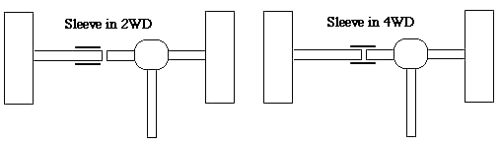
When you engage 4WD a switch on the transfer case changes a set of air valves under the hood. This causes vacuum to be applied to the passenger side tube of the actuator and it pulls the sleeve over to the right and connects the drivers side axle shaft to the differential. Once the splines on the sleeve and the splines on the shaft are aligned the sleeve slides toward the passenger side and the front drive is engaged There are two switches that must be in the closed position for the 4WD light to come on. The first switch is controlled by the position of the transfer case shift lever. The second light is on the ADD actuator and it turns on after the sleeve has moved into the right (locked) position.

Trouble-shooting your ADD system
Trouble-shooting is often a process of elimination, test parts, figure out what works then move on to the next. There are more than 50 individual parts that make up the ADD system and creating a flow chart that includes every possible solution is beyond the scope of the article. For trouble shooting the electrical and vacuum sections of the ADD system you will need the Toyota factory service manual and excellent trouble shooting skills.

The most common problem is damage, deterioration, or mis-routed vacuum hoses. To ensure the vacuum lines are routed properly, they are marked with either a blue or brown tracer stripe on the hoses. These hoses should match up with the corresponding VSV under the hood. In some cases during engine or collision repairs, these hoses get routed incorrectly or left disconnected altogether.

When the transfer case gear shift is shifted into 4WD, the ADD system is actuated by the operation of the ADD solenoids located under the hood on the passenger side wheelwell. The solenoids are supplied voltage from the ADD relay which depending on the type of transmission the vehicle is equipped with, has it's ground completed by both a Transfer Position Switch and a Transfer Pressure Switch (V6 with automatic transmissions), or a Transfer Indicator Switch (4cyl.-- manual trans.). These solenoids control the vacuum signals to the ADD actuator which is mounted on the front axle. This actuator engages a sleeve inside the differential via an "intermediate shaft" which is attached to the driver's-side side gear shaft and clutch mechanism.

If the ADD system does not properly engage the front drive mechanism, the first items to check are the vacuum supply hoses. First, look under the hood and locate the ADD solenoids. Ensure that the vacuum hoses are connected to the solenoids or vacuum switching valves (VSV) as they are commonly called by Toyota. Next, look at the hoses at both the differential and vacuum reservoir located in the R/F wheelwell. Make sure all hoses are connected and not torn, cracked, or otherwise in poor condition. Once the system is engaged or disengaged from 4WD, it will stay in that position. Basically, if the system is not functioning, the vehicle can be placed in either 2- or 4- wheel drive manually with a vacuum source for testing. If you plan to leave the ADD system disconnected you will need to apply vacume from the engine to make sure the front end does not unlock.

The ADD relay can be inspected for operation as well. This relay is located under the instrument panel on the passenger side of the steering column. Check for continuity between terminals 2 & 6 and 1 & 3 (see diagram). Upon applying 12 volts continuity between terminals 1 & 4. Replace the ADD relay if it fails the above tests. The VSVs or ADD solenoids can be inspected as well. This is another resistance check so a DVOM is needed here as well. Disconnect the electrical connector from the VSV and check to see if the resistance is between 38-45ohms. Replace the VSV if the resistance doesn't meet this specification. A function check of the VSVs will show if the valves are working internally. By applying battery voltage to the connector and blowing air into the lower hose fitting, air should come out of the top fitting and not the lower "filter" on the VSV. Once battery voltage is removed, air should pass through the filter and not the upper hose fitting. A final check can be made of the ADD indicator switch which is located on the ADD actuator itself. This switch acts like a brake light switch. Remove the switch from the actuator. Depress the switch button and check for continuity between the terminals of the connector. If there is no continuity, replace the switch. Depending on the type of wheeling you use your ADD truck for, you may decide to retain the ADD system or eliminate it all together.

Testing the engagement of the ADD sleeve is relatively easy requiring only a vacuum source. First disconnect the two vacuum hoses from the ADD actuator unit and put the truck in 2WD on level ground. If your truck is equipped with manual hubs, lock the hubs for this test.

Testing for 2WD: Put a hand vacuum pump on the drivers side and apply 15 lbs of vacuum. This will pull the actuator into the 2WD position. At this time you should be able to turn the front drive shaft by hand with out the front axle shafts turning. The actuator should be able to hold the vacuum without leaking.

Testing for 4WD: Now place the hand vacuum on the passenger side of the actuator and apply 15 lbs of vacuum. The sleeve should slide into the locked 4WD position. you should no longer be able to turn the front drive shaft (by hand) as the add unit is now engaged. The actuator should be able to hold the vacuum without leaking.

Permanently locking the ADD unit: There are 2 hoses connected to the ADD actuator. The vacuum line on the passenger side of the actuator puts shaft into the diff and the other side removes it. I removed the vacuum tank and vacuum switches. Then I connected a single vacuum line to the passenger side of the actuator to keep it locked. Then I and caped the driver side tube. This will prevent the ADD system from unlocking. The switches can be found behind the battery on the inside right fender, the vacuum tank is in front of the front right tire under the fender. Be sure to cap the vacuum feed from the engine to the switches or remove the "T" feeding it all together. I have found that the transfer case shifts much easer without the ADD system

Some specific troubleshooting threads copied from yotatech.com

1) “Make sure you test the transfer case rear actuator with like a battery charger on 12v 2amp load and then use like a couple pieces of wire to touch pins 2 & 3 with the positive and ground leads and then reverse the polarity to run the actuator into 4WD and then back into 2WD mode. If your actuator will move in and out by jumpering it, then most likely it is okay and not at fault.

You can test the front diff ADD actuator with vacuum from a vacuum pump and verify that you can turn the driveshaft in 2wd mode and then test the other side and you shouldn't be able to turn the front driveshaft.”

2) I've got a 99 4Runner LTD V6 with auto trans and it has the M/M - 4WD style shifter in the transfer case.

One day last week I decided to use the M/M button instead of manually shifting the lever into 4HI, and when I did the 4WD light on the dash blinks. I tried shifting it back into 2HI and the light still blinks all the time. I jacked up the 4Runner on jackstands and it is in fact in 4WD mode and I could feel it when I had to drive on dry pavement with the front end still being engaged in 4WD. One rear tire was spinning and both front tires were spinning for a while, but then it was just the left front and rear tire spinning up in the air.

I jumpered the rear transfer case actuator with 12v on pins 2 & 3 and then reversed the polarity to run the actuator into 4WD and then back into 2WD mode. I did this several times. It worked like it should back and forth without any problems. I decided to put into 2WD mode on the rear actuator and then start up the 4Runner. The light was out and I could tell that I was in 2HI like it should be.

I tested the vacuum lines from the ADD solenoids to the front diff, and they both held 20# of vacuum and did not bleed down. I tested the line from the T to the vacuum canister in the left front wheelwell, and it held vacuum. I tested each line down at the front diff and both lines held 20# of vacuum, but I could not hear the collar in the front diff move either time. I tested the vacuum line from the intake down to the 1 way valve and it held vacuum as well.

Then I tested each ADD solenoid and the brown one had 37 ohms of resistance, and the blue one had 39 ohms of resistance. I read that they are supposed to have 38-45 ohms, so the brown valve is close to being within factory specs.

At this point since I cannot hear the collar move at the front diff actuator, I'm leaning towards it as the culprit or the brown VSV valve.

I swapped out the 4WD computer and it still is doing the same thing.

I'm leaning towards the front diff actuator being stuck since I can apply vacuum directly to each side of it and I don't hear the collar moving back and forth.

But I need to jumper the transfer case actuator back into 2HI mode and then jack up the front end and see if the axle shafts are still gonna turn.

I'm gonna test the ADD solenoids by jumpering power to them with the electrical connectors unplugged and apply vacuum to the lower hose I believe to see if it will exit out the top or not. Then I'll disconnect power from it and see if it will let the vacuum bleed down.

I got to do some testing of some of the sensors for the transfer case tonight and the actuator on the front diff.

I unplugged both vacuum lines off of the front diff and I applied vacuum to the driver's side line on the actuator and then I tried to turn the front driveshaft, and it wouldn't turn so it was acting like it was in 4WD. Then I switched and applied vacuum over on the passenger side vacuum line on the actuator and it allowed me to turn the front driveshaft by hand being it was in 2WD. At least that part is normal.

Then I removed the two sensors one at a time on the back of the transfer case above the rear actuator. I put my multimeter on continuity and then put both leads on each of the 2 pins on the sensor. With the sensor extended out, there was no circuit. Then when I pushed the button on the sensor in, it completed the circuit and gave me tone. I repeated the same thing on the other sensor on the back of the transfer case, and it did the same thing. So those appear to be normal.

I need to pull the 2 most forward sensors off of the left side of the transfer case near the top to check them yet. Also, I need to do the same for the sensor on the front diff by the actuator to test it.

I can manually shift the transfer case lever, or push the M/M button and get it to go into 4WD mode (and it is from my previous test), but when I shift it back into 2HI it will not disengage the front end. I've tested all the vacuum lines in the 4wd system and everything holds vacuum.

Here's my question.

If the front diff sensor is bad, it will not tell the computer that it is locked or unlocked, resulting in the system thinking that it is in AWD mode right? My 4wd light on the dash just blinks and never goes solid like it should if the front end tells the computer that it is locked in.

I already replaced the 4wd computer with another good one and that didn't change anything either.

I need to test the 2 ADD solenoids with a 12v and vacuum test done on them and verify that they are in working order. I have to buy a sensor socket or a stubby end wrench to remove the 2 more forward sensors at the top of the transfer case and the front diff sensor yet so I can test them like I tested the first 2 tonight.

Here's an update from some troubleshooting that I just did.

First off, I had to shift the t-case into 4HI this morning as I had 8 inches of new snow to drive to work in. The 4wd light on the dash just started blinking and would not totally lock up into 4wd mode, but you can feel the front end is engaged. Then at lunch time I had to run into town for some supplies for work and the roads had thawed out enough to not use 4wd, so I shifted the t-case lever back into 2HI, but the 4wd light was still blinking like it has done for the last few weeks. I went to Walmart to get the supplies and shut off the 4runner. When I came back out and started the 4runner, the light went out on its own and I was in 2wd mode for real this time. So then I was thinking WTF is going on with this thing? I went home after work and the roads were a little bit icy so i pulled my t-case lever into 4HI and the lights blinked for a couple times and then went solid and showed that the 4wd system was indeed locked into 4x4 mode. I shifted it back into 2HI and it disengaged the front end and I was in 2wd mode. I was like well isn't that strange? It's working again. While I was in 2HI I pushed the M/M button in and it blinked a few times and then it went solid with only the 4 lights resembling the 4 tires of the 4runner being lit. So now M/M was working correctly again also. Hmmm? Even though it was working, I decided to check the last 3 sensors for the 4wd system to determine which one is causing the problem.

So I bought a 1 1/16" end wrench and I took a grinder and cut the wrench into 2 pieces, the box end has about 4" of wrench attached to it, and the rest is on the open end side. There are 2 sensors towards the top of the t-case on the driver's side - Front one is BLUE, and the Rear one is GREEN. I took the box end wrench piece and I put it over the green sheathed sensor and used a pry bar to pry up on the bottom side of the wrench to break loose the sensor. BE VERY CAREFUL OF THE VACUUM LINE AND THE WIRING HARNESS THAT RUNS ALONG BY THE SENSORS SO YOU DON'T DAMAGE THEM! I removed that sensor and used a continuity check on the Multimeter by putting both leads from the meter on to each pin on the pigtail, then I pushed down on the button of the switch and it gave me an electrical readout. Then I removed the front blue sheathed sensor in the same way, and performed the same test to it. It gave me a similar readout on the multimeter. Then I installed the 2 sensors in the reverse order starting with the blue one and then the green one, and I tightened them down and plugged them back in. Then I removed the rear skidplate from the front end and I unplugged the sensor switch that is by the front diff actuator. I took the open end wrench piece that I cut the wrench from and broke loose the sensor. I removed it and used the Multimeter on it with each lead on both pins of the sensor and then I depressed the button on the sensor. It gave me NO continuity beep or an electrical readout on the Multimeter. I depressed it repeatedly with it only giving me a beep once in a while. So then I put it back together and I tested the 4wd system on the ice again. Now my 4wd dash light is blinking in 4HI mode and in 2HI mode again and the front diff will not disengage. It's now doing the same thing again as it has for the last few weeks.

So at this point in time, I'm at the conclusion that the front diff sensor is whacked out. If you think about it, it is the sensor that tells the 4wd computer that the front end is either locked into 4wd mode or unlocked into 2wd mode. It is also the sensor that truly tells you that your 4wd system is engaged or disengaged by giving you the light on the dash. The button on the sensor gets depressed when the front diff actuator goes into 4wd lock mode, and then it gets extended back out when the front diff gets disengaged from being shifted back into 2HI.

So I'm headed to Toyota in the morning to see if they have the front diff sensor, as I'm 95% sure it is the one that is messing up my 4wd system.

Okay fellow yota owners;

I went to Toyota today and they had to order both sensors that I wanted. I wanted the Center diff lock sensor which is on the passenger side of the transfer case, and the sensor for the front diff.

Here's the part # for the front diff sensor - 84222-35070 and I got it for $36.94.

You guys will be happy. The parts guy at Toyota let me look at the FSM for a 99 4Runner and he photocopied what pages I wanted out of it.

The "BLUE" ADD solenoid is your 4WD solenoid, and the "BROWN" ADD solenoid is your 2WD solenoid.

I got the wiring schematics for the 4wd system with the 2-4 select switch (M/M) transfer case, the exploded diagrams of the t-case, and the description page of what each sensor does. I'll get them scanned and posted in the thread so that all of you will have some good reference material for troubleshooting.

Have you checked the sensor on the front axle up by the front diff actuator yet? This is the one that is causing mine to stick into the blinking 4wd light mode sometimes. I removed mine and tested it with the multimeter by putting the pos lead on 1 pin and the neg lead on the other pin and then pushing the button in. This should give you a continuity beep or a readout on the screen of the multimeter. If it doesn't do anything when it is pushed in, then that sensor is bad.

3) 2000 4runner limited (which means it has a center lock diff, push button 4wd on the shift tower, and vacuum controlled ADD)
Problem: 4wd light flashes on the dash when the the transfer case is in 2wd and the push button 4wd is disengaged. It engages into 4wd by moving the transfer case lever or via the push botton 4wd, but does not disengage from 4wd. This is verified when the vehicle is on jack stands and the front axle is still locked as well as the front driveshaft.

1. Check Transfer Case Actuator
1.1 Remove both switches on the Actuator and perform continuity test when the plunger was depressed.
1.1.1 Continuity when plunger is depressed, and no continuity when plunger is released.
1.2 Apply power to the actuator connector (mine is 2 rows of 3 plugs not the 6 plug) motor to engage and disengage actuator.
1.2.2 Remove the heater core relay (it is the same part number as 4wd relay but easier to access) and provide power via relay to the actuator plug.
1.3 Check for continuity at transfer case push button selector switch.
1.3.1 Continuity when button is depressed, and no continuity when it is released.

2. Check Automatic Differential Disconnect (ADD) system
2.1 Remove switch on ADD body and performed same continuity test as on the transfer case.
2.2 Remove ADD Actuator and perform vacuum test (you can do this with it on as well, but I wanted to visually inspect it too)
2.2.1 With a handheld vacuum pump attached to port A (bell housing side) and verify fork moves to the right (disengages).
2.2.2 With a handheld vacuum pump attached to port B verify the fork moves to the left (engages).
2.2.3 Reinstalled ADD actuator assembly and switches
2.3 Check vacuum lines in ADD system
2.3.1 With a handheld pump checked that vacuum lines held pressure to and from the ADD actuator from the ADD solenoids. Between the solenoids. To and from the the intake manifold and the canister.
2.4 Check ADD Solenoids
2.4.1 Check for resistance of each solenoid (B/w 38-45 ohms).
2.4.2 Remove Solenoids and check for vacuum when powered.
2.4.2.1 Air flows into port E (further from the filter) and out port F (closer to the filter).
2.4.2.1 When power is cut air flows into port E and out the air filter, but not port F.
2.4.3 I had a hard time verifying the vacuum under power, and tried a few different methods to test air flow, but wasn't convinced. So at that point I replaced the both solenoids. This didn't solve the problem.
2.5 Check power to ADD solenoids
2.5.1 Check continuity in green solenoid with transfer case in 4wd or push button 4wd engaged.
2.5.1 Check continuity in brown solenoid with transfer case in 2wd or push button disengaged.

Have you taken the round cover off the actuator and cleaned up the corrosion that you will find along the contact path traces?

Yup, gently pried off the cover to the transfer case actuator and it looks in good condition. Applied power to terminals 2 & 3 (bottom right on the 2 row connector) and it engages and disengages. Both switches are operating correctly. Takes a 27mm deep well socket or wrench to remove both switches

I went to work ticking my way down the list today.

So position switches (27mm wrench size) - there are two on the transfer case body, one on the passenger side of the transfer case, two on the driver side of the t case, and one on the front diff. All of those tested okay. They have continuity when the plunger is depressed and no continuity when released. The three on top of the t case were hard to access and I ended up just dropping the case to access them.

I removed the front ADD assembly - it was clean inside- and tested that it operates the fork under air pressure, which it did. I threw it back on and checked that it operated when air is applied from the solenoids (I used a handheld pump, and checked it again by just flipping the lines from the solenoid).

At this point I suspected it was the solenoid that wasn't opening the valve for air pressure to disengage the ADD fork, so I ran out and threw in a new one to no avail. I tested the connections leading to the solenoid, and when Multi Mode is engaged I get continuity to the blue solenoid. When it is disengaged I don't get any continuity to the brown solenoid. My guess is the ecu isn't getting the correct reading from the transfer case and isn't supplying power to the solenoid, or the ecu is just malfunctioning. I can unlock the diff by providing air pressure, but the front driveshaft is always locked in to the transfer case regardless of what I do.

At this point I am leaning toward the 4wd relay or the ECU. Does that sound like the next rabbit hole to chase?

That your front driveshaft is locked tells me the transfer case isn’t in the position it’s supposed to be in. with the stick in 2wd the front driveshaft should free spin.

I think you are right.
I dropped the t case out so I could check if the actuator forks are internally bound in the case. I could move it throughout the range by hand and also by jumping the actuator motor that it moved throughout the range. Rechecked all 5 switches on the case and actuator. Double checked the “timing” of the limit switch when in 2wd, put it all back together and threw it on.

So my actuator shaft was in 2wd (pulled all the way back), my motor was in 2wd, and the front drive shaft spun freely, but the hubs were locked. No problem, a little vacuum pressure to unlock the hub and now everything is in 2wd. Turn the key, with transfer j shift in 2wd, and a few seconds later flashing 4wd lights and it Locked everything back into 4wd

When you check your switches, you have to check for continuity along the WHOLE stroke of the sensor. Just because you get appropriate signal at the top and bottom, that isn’t where the sensor reports while in service. You need to measure from like an 1/8” off each max.

4) The vacuum switching valves control when vacuum is applied to the front ADD actuator for 4WD and 2WD modes.

The one switch at the front diff when the switch is closed tells the 4WD computer that the front diff ADD actuator is engaged in 4WD mode and that will allow the 4wd system to lock the transfer case into 4wd mode.

The center differential lock switch when closed tells the 4wd computer that the front end is engaged in 4wd mode and that the t-case can be locked into 4wd mode.

The L4 position switch on the t-case must send a signal to the computer to let it know that the t-case shifter has been placed into the Low 4wd position.

The neutral position switch must send a signal to the 4wd computer that the shifter has been placed into the neutral position. I haven't dived that far into the 4wd system as much lately since mine has been working great since I isolated my 4wd system issue and fixed it with a front diff switch.
Note locations of 4WD position switches on transfer case: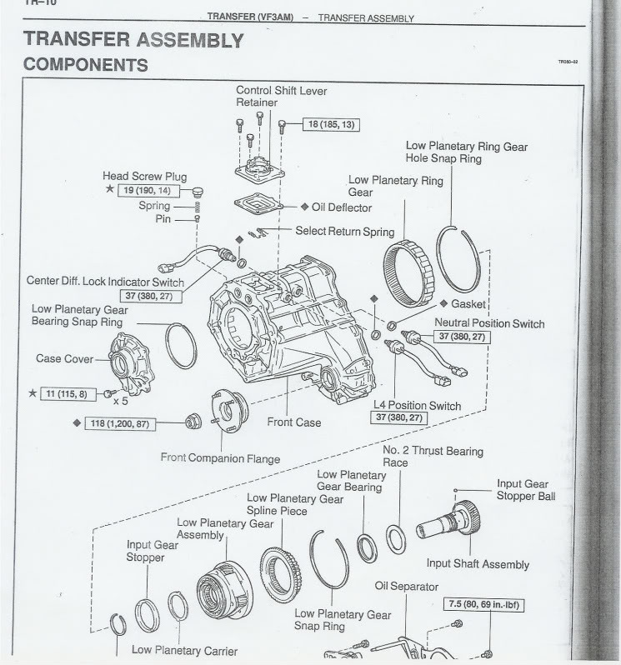
More on switch checks:

FIXED...FIXED..FIXED...1999 4Runner Limited 4WD stuck!

I took several pics and tried to make a simple step by step for other newbies if their trouble ends up being the front diff switch. Like Doug said a great first place to start. You will need ratchets that will fit a 12mm socket for the bolts of the skid plate and a 27mm socket YES 27mm! You more than like likely wont have this. It runs about $8 at Lowe's, just a regular one, NOT the deep socket one. You will also need a multimeter which are very cheap at Lowe's as well or Radio Shack. I borrowed one from a friend.

Step 1 - Remove your front skid plate if you have one. There will be 4 bolts.
Step 2 - Locate the front differential switch, it is attached to the front actuator. This is located in front directly behind the oil pan.

Step 3- Remove the attached wire from the switch. There is a tab on the wires Grey portion that you simply push down on with your finger and at the same time you pull.

Step 4- Remove the switch. Now with the wire removed, you will need the 27mm socket and 1/2 ratchet to loosen the switch. It is a tight fit like someone here in the forum said but it you attach the socket first and then put the handle of the ratchet up first in the space you will then be able to slip it on the switch and loosen it and then once loosen use your fingers to remove it the rest of the way. You cant loosen it all the way with the ratchet or it will get stuck.

Step 5 - Test the switch. Get the multimeter and touch both pins with a separate wire from the meter. With the plunger out/ normal you will get no reading. Next push the plunger with your thumb and check reading you should hear a tone or see continuity. If not your switch is bad. Mine was bad. Part number is 84222-35070.

Other switches…

There are a total of 6. You found the 2 on the transfer case actuator. If youre on the passenger side of the transfer case you'll find 1 on top of the transfer case by the shift lever. It's tight up there and theres a vacuum line, so be careful of that and dont knock it loose. On the drivers side you have 2. You have to take the rear one out first then the front one. To put them back in start with the front one then the rear one. The other one one is on the front actuator(thats the other actuator youre looking for). Its right above the cross member in the front. Very tight up there. Its vacuum operated, not electrical like the transfer case one.
As far as checking your transfer case actuator, jack ur truck up off the ground(all 4 wheels). U apply 12v to the 2 pins on the bottom row on the right. Bottom row is the one further away from the actuator and the wires for those pins are thick solid green. Positive on one and Neg on the other. I dont remember which one will make it go in or out of 4wheel drive, but u reverse the Pos and Neg to do the opposite. If the Tcase actuator is bad u either wont hear any movement or you'll hear that constant clicking/grinding. After you do that, leave the connector unpluged. With the truck running and in gear, one of the front tires should be turning along with the back ones. Reverse the Pos and Neg and see if it comes out of 4wheel drive. If all that works, plug the connector back in. Make sure if the Tcase is in 2wheel drive the push button is not depressed. With the trucked still jacked up, see if you can push the button and make it go in 4WD. You should be able to hear the Tcase click and move. Lights on the dash should be solid at that time.

If non of that works, you may have a problem with the VSV which controls the vacuum actuator.
5) Electrics…
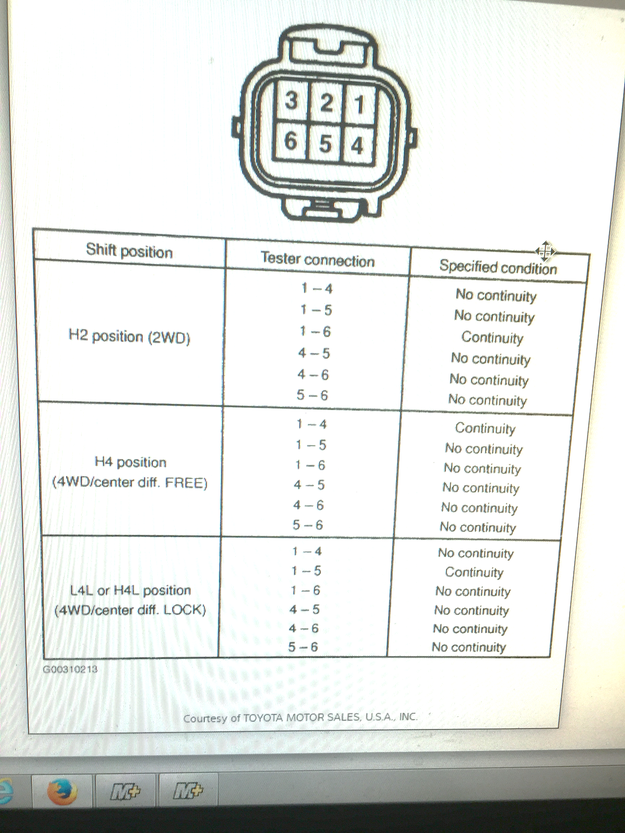

6) Is this useful for reassembling the transfer case actuator?

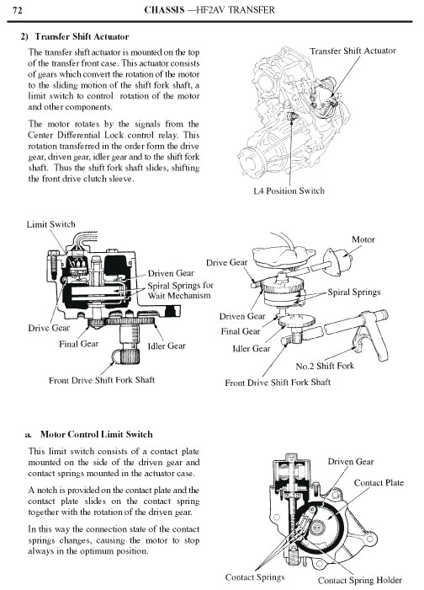
How did you put the new actuator on the fork shaft and know that it is "in time" or in the correct gear (I guess they come set in 2WD)?

7) Transfer case actuator motor clean-up:
I have a 2001 Sport that started (about 9 months ago) having intermittent problems going into 4WD. At first it would go into 4WD (you could hear the actuators lock in and it was obvious that it was locked in) but the green and orange lights would keep flashing. Cycling it in and out a few times would eventually get it where the lights would work correctly.

A few months later it would not go into 4WD but the lights would start flashing. Fortunately I found a way to get it to cycle in during a couple of needed times by climbing underneath and disconnecting the 6 pin connector on the xfer case actuator, pressing the 4WD button and then reconnecting the 6 pin. At this point I also removed all of the sensor switches and tested them, finding none were having an issue. I also noted that the breather tube on the xfer case actuator was cracked and just barely staying in place.

About a month ago I started having issues where it would get stuck in 4WD and not come out and other times where it would not want to go into 4WD at all. I again pulled and tested all of the switches, re-seated all connectors, etc... and could not find anything wrong. So I decided to pull the black cover/drive motor off the xfer case actuator to see if there was an issue with the contacts inside it. As I pull it off, water starts coming out of the actuator assemble (perhaps an ounce at most). The motor spiral gear, gear that runs the actuator into place and the contact race tracks in the cover are all covered in a pasty, greasy rust.

So I cleaned out the water, rust and old grease from everything and re-greased it all. Put it all back together and boom, everything started working like new.

Obviously not the same issue as the original post, but I think this thread is the most complete collection of info related to these types of issued and hope my input will help somebody else.

Just a couple quick notes on pulling the motor cover off the actuator:

1. Loosen the 10mm bolts but keep them threaded in a few turns until you work the cover off. Mine was a little tight and I did not want to have stuff flying around if it came flying out of my hand.

2. After you get it off - leave the main drive gear in place. I am not sure if you can pull it off easily, but I had read that some folks had issues re-timing it after taking it off.

3. I took the drive motor cover off and pulled the spline shaft out of the cover. If you do this be very careful pulling it out as there are springs and small ball bearings on the ends of the shaft that can and will go flying. In retrospect, I did not need to pull it apart. Re-assembly of the motor is challenging as there are little spring-loaded motor contacts that are a pain.
ADD-actuator fork-sleeve disconnect (rare):

“I had a very strong suspicion that the issue was ADD related. Luckily I still had my old diff/add mechanism lying around, so I took it apart and started brainstorming. I removed the actuator and looked inside... There is a sleeve that should be moved left/right to unlock/lock the passenger side CV axle. There is a groove in this sleeve for the fork on the actuator that moves it. Turns out if the sleeve is moved all the way to the left (it will move further beyond unlocked position) the actuator will bolt up and the fork will miss the groove. The fork will still have full travel range, thus activating the limit switch which activates the 4wd dash light, but the locking sleeve will never move with it, being stuck in unlocked position.”

